Theories on Origin of Life
Several attempts have been made from time to time to explain the origin of life on earth. As a result, there are several theories which offer their own explanation on the possible mechanism of origin of life. Following are some of them:

Theory of Special Creation
According to this theory, all the different forms of life that occur today on planet earth, have been created by God, the almighty. This idea is found in the ancient scriptures of almost every religion. According to Hindu mythology, Lord Brahma, the God of Creation, created the living world in accordance to his wish. According to the Christian belief, God created this universe, plants, animals and human beings in about six natural days. The Sikh mythology says that all forms of life including human beings came into being with a single word of God. Special creation theory believes that the things have not undergone any significant change since their creation.
The theory of Special Creation was purely a religious concept, acceptable only on the basis of faith. It has no scientific basis.

Theory of Spontaneous Generation
This theory assumed that living organisms could arise suddenly and spontaneously from any kind of non-living matter. One of the firm believers in spontaneous generation was Aristotle, the Greek philosopher (384-322 BC).
He believed that dead leaves falling from a tree into a pond would transform into fishes and those falling on soil would transform into worms and insects. He also held that some insects develop from morning dew and rotting manure. Egyptians believed that mud of the Nile river could spontaneously give rise to many forms of life. The idea of spontaneous generation was popular almost till seventeenth century. Many scientists like Descartes, Galileo and Helmont supported this idea. In fact, Von Helmont went to the extent stating that he had prepared a 'soup' from which he could spontaneously generate rats! The 'soup' consisted of a dirty cloth soaked in water with a handful of wheat grains. Helmont stated that if human sweat is added as an 'active principle' to this, in just 17 days, it could generate rats!
The theory of Spontaneous Generation was disproved in the course of time due to the experiment conducted by FransiscoRedi, (1665), Spallanzani (1765) and later by Louis Pasteur (1864) in his famous Swan neck experiment. This theory was disapproved, as scientists gave definite proof that life comes from pre-existing life.

Theory of Catastrophism
It is simply a modification of the theory of Special Creation. It states that there have been several creations of life by God, each preceded by a catastrophe resulting from some kind of geological disturbance. According to this theory, since each catastrophe completely destroyed the existing life, each new creation consisted of life form different from that of previous ones.
A French scientist Georges Cuvier (1769-1832) and Orbigney (1802 to 1837) were the main supporters of this theory.

Cosmozoic Theory (Theory of Panspermia)
According to this theory, life has reached this planet Earth from other heavenly bodies such as meteorites, in the form of highly resistance spores of some organisms. This idea was proposed by Richter in 1865 and supported by Arrhenius (1908) and other contemporary scientists. The theory did not gain any support. This theory lacks evidence, hence it was discarded.

Theory of Chemical Evolution
This theory is also known as Materialistic Theory or Physico-chemical Theory. According this theory, Origin of life on earth is the result of a slow and gradual process of chemical evolution that probably occurred about 3.8 billion years ago. This theory was proposed independently by two scientists - A.I.Oparin, a Russian scientist in 1923 and J.B.S Haldane, an English scientist, in 1928.
According to this theory,
- Spontaneous generation of life, under the present environmental conditions is not possible.
- Earth's surface and atmosphere during the first billion years of existence, were radically different from that of today's conditions.
- The primitive earth's atmosphere was a reducing type of atmosphere and not oxidising type.
- The first life arose from a collection of chemical substances through a progressive series of chemical reactions.
- Solar radiation, heat radiated by earth and lighting must have been the chief energy source for these chemical reactions.

Miller’s experiment
Miller–Urey experimentor Miller experimentwas a chemical experiment that simulated the conditions thought at the time to be present on the early Earth, and tested the chemical origin of life. Specifically, the experiment tested Alexander Oparin's and J. B. S. Haldane's hypothesis that conditions on the primitive Earth favored chemical reactions that synthesized more complex organic compounds from simpler inorganic precursors. Considered to be the classic experiment investigating abiogenesis, it was conducted in 1952 by Stanley Miller, under the supervision of Harold Urey, at the University of Chicago and later the University of California, San Diego and published the following year.

After Miller's death in 2007, scientists examining sealed vials preserved from the original experiments were able to show that there were actually well over 20 different amino acids produced in Miller's original experiments. That is considerably more than what Miller originally reported, and more than the 20 that naturally occur in life. There is abundant evidence of major volcanic eruptions 4 billion years ago, which would have released carbon dioxide (CO₂), nitrogen (N₂), hydrogen sulfide (H₂S), and sulfur dioxide (SO₂) into the atmosphere. Experiments using these gases in addition to the ones in the original Miller experiment have produced more diverse molecules. Some evidence suggests that Earth's original atmosphere might have had a different composition from the gas used in the Miller experiment. But prebiotic experiments continue to produce simple to complex compounds under varying conditions.

Experiment
The experiment used water (H₂O), methane (CH₄), ammonia (NH₃), and hydrogen (H₂). The chemicals were all sealed inside a sterile 5-liter glass flask connected to a 500 ml flask half-full of liquid water. The liquid water in the smaller flask was heated to induce evaporation, and the water vapour was allowed to enter the larger flask. Continuous electrical sparks were fired between the electrodes to simulate lightning in the water vapour and gaseous mixture, and then the simulated atmosphere was cooled again so that the water condensed and trickled into a U-shaped trap at the bottom of the apparatus.
After a day, the solution collected at the trap had turned pink in colour. At the end of one week of continuous operation, the boiling flask was removed, and mercuric chloride was added to prevent microbial contamination. The reaction was stopped by adding barium hydroxide and sulfuric acid, and evaporated to remove impurities. Paper chromatography revealed the presence of glycine, α- and β-alanine. Miller could not ascertain aspartic acid and GABA, due to faint spots.
In a 1996 interview, Stanley Miller recollected his lifelong experiments following his original work and stated: "Just turning on the spark in a basic pre-biotic experiment will yield 11 out of 20 amino acids.

As observed in all subsequent experiments, both left-handed (L) and right-handed (D) optical isomers were created in a racemic mixture. In biological systems, most of the compounds are non-racemic, or homochiral.

The original experiment remains today under the care of Miller and Urey's former student Jeffrey Bada, a professor at UCSD, at the University of California, San Diego, Scripps Institution of Oceanography. The apparatus used to conduct the experiment is on display at the Denver Museum of Nature and Science.
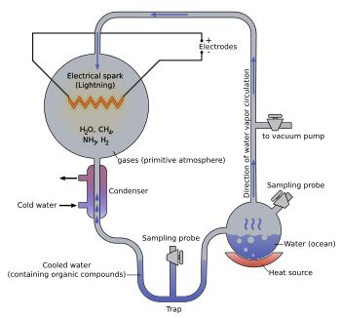

The Miller-Urey Experiment (1950s)
- They mixed gases thought to be present on primitive earth:
  - Methane(CH₄)
  - Ammonia(NH₃)
  - Water(H₂O)
  - Hydrogen (H₂)
  - No Oxygen
- They then electrically sparked the mixture to signify lightning. The results were amino acids, the building blocks of proteins.
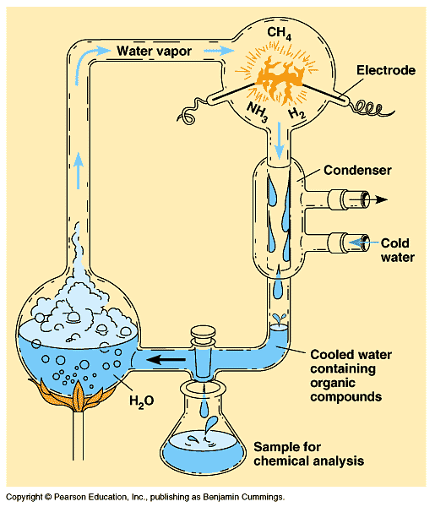

EVIDENCES AGAINST THE THEORY OF SPONTANEOUS GENERATION: Theory of spontaneous generation was criticized by Lazzaro spallanzani, Francisco redi and Louis Pasteur. These great scientists performed well designed scientific experiments to disprove the theory of spontaneous generations.
1. Redi’s experiment: Francisco redi did conclusive and well designed experiment to disapprove the theory of spontaneous generation. He placed meat and fishes in 3 separate jars. Jar No. 1 was left open, No. 2 was covered with gauze and the third one was covered with paper. The meat/fishes decayed in all three jars and attracted flies. In Jar No. 1, flies entered and layed eggs which eventually gave birth new larvae. Whereas in Jar No. 2, flies couldn’t be able to enter and no larve was found inside the jar. But flies laid eggs on gauze that produced larvae. This has conclusively proves that organisms arise from the pre-existed organism rather than non-living matter.
2. Spallanzani’s Experiment: The experimental setup is given in the Figure 3.3. In the designed experiment to test the validity of theory of spontaneous generation. In this experiment, spallanzani has prepared animal or vegetable broth and boiled them for several hours and then either remained open or sealed immigately. These broth remained free from microorganism growth. He concluded that high temperature boiling had killed all microorganisms and in the absence of microorganism life could not appear. The broth left open or exposing of sealed broth shows growth of microorganisms.
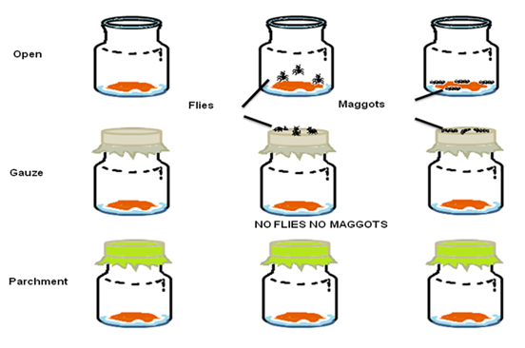
Figure 3.2 : Redi’s Experiment to disprove the theory of abiogenesis.

